**PROJECT TITILE**

**Self-Updating Security Patch Script**

**V UDAYKIRAN SHASHIDHAR**

**CYBER SECURITY CYBER SECURITY MENTOR**

**TAH1407251705 TEKS ACADEMY**

**TEKS ACADEMY 9603343287**

**9182441078**

**Abstract :**

Securing our systems today is a top priority, especially with new threats constantly emerging. Operating systems and applications are always getting updates to fix security holes, boost performance, and make things more stable. But if you're stuck doing these updates by hand, your systems can be left vulnerable for too long.

That’s where the Self-Updating Security Patch Script comes in. Think of it as a helpful assistant that automates the whole process on Linux systems, particularly in the Kali Linux environment. It uses the system's own tools, like apt, to find, download, and install the latest security updates automatically. And thanks to a tool called “cron”, it runs on a schedule you set, so you never have to remember to do it yourself.

The script also keeps a detailed diary of everything it does, recording when updates happen and what gets installed. This helps administrators keep a clear record and makes it easy to troubleshoot any problems. To keep things tidy, a tool called “logrotate” makes sure these log files don’t get too big and clog up your disk space.

By using this script, you can:

* Make sure critical security patches get installed on time.
* Cut down on downtime caused by old or vulnerable software.
* Save yourself from the tedious work of manual maintenance.
* Stay compliant with security rules that require your systems to be up to date.

Essentially, this project makes your systems tougher against cyberattacks, frees up your time, and promotes a smarter, more proactive approach to security without making extra work for you.

**2. Problem Statement**

In today's digital landscape, our systems are constantly under threat from cyberattacks, malware, and newly discovered weaknesses. Software and operating system developers are always releasing security patches—think of them as critical fixes—to protect us from these dangers.

But here’s the problem: a lot of us, both individuals and organizations, don’t install these updates fast enough. Maybe we're too busy, we forget, or the process is simply too much of a hassle to do manually.

When we delay these crucial updates, we're leaving the door wide open for trouble. Hackers can exploit these unpatched vulnerabilities to steal data, cause damage, and take down our systems. This can lead to costly downtime and major financial losses.

On systems like Kali Linux, staying secure means manually running updates with tools like apt or yum. If you’re a system administrator, this responsibility falls squarely on your shoulders. The more you put it off, the more vulnerable your system becomes. And if you're managing multiple machines, this task becomes a huge, time-consuming chore where it's easy to make a mistake and miss an important update.

**In Simple Terms**

Imagine your computer's security is like the locks and walls of your house. Security patches are like fixing a broken lock or patching a hole in the wall. If you don't fix these issues, a thief (or a hacker) can easily get inside. Right now, with many systems, you have to remember to check and fix these problems yourself. If you forget or get busy, your house is an easy target.

**The Solution: Why We Need an Automated Fix**

We need a better way to handle this. Our goal is to create a solution that will:

* **Automate updates:** Automatically check for and install security patches, so you don't have to.
* **Prevent human error:** Take the chance of forgetting an update out of the equation.
* **Save time:** Free up system administrators from the tedious task of manually updating multiple machines.
* **Keep a record:** Log every update for easy auditing and future reference.

**3.** **Project Objectives**

This project aims to solve the problem of manual security updates by building a system that handles everything for you. Here’s a breakdown of what we want to achieve:

**Automate Security Patch Updates**

The core of this project is to take the hassle out of updating your system. Instead of manually running commands like sudo apt update && sudo apt upgrade every day, our script will do it for you automatically in the background. This ensures your system is always protected with the latest security fixes, keeping it safe from cyber threats.

**Ensure System Security and Stability**

By keeping your system consistently updated, we drastically reduce the risk of it being compromised. Outdated systems are easy targets for hackers, malware, and ransomware. Our automated solution makes sure these vulnerabilities are patched quickly, creating a more stable and secure environment.

**Maintain Detailed Logs of Updates**

We'll record every update action in a **log file**. This log acts as a history book for your system, showing you what was updated, when it happened, and if any errors occurred. This is incredibly useful for troubleshooting—if something goes wrong after an update, you can simply check the logs to pinpoint the cause.

**Run Updates Automatically at Scheduled Times**

This project uses **cron jobs** to schedule the update script to run at specific times, like every morning at 3 AM. This guarantees that your system is updated consistently without you ever having to lift a finger.

**Manage Logs Efficiently Using Log Rotation**

Log files can get huge over time and eat up disk space. We'll use **logrotate** to automatically manage these files, archiving old logs and creating new ones. This keeps your storage tidy and prevents you from running into disk space issues.

**Make the Solution Easy to Use and Maintain**

Finally, we want this solution to be straightforward and accessible for everyone. The script will be simple to set up, easy to read, and modifiable, so even beginners can use it and make improvements down the line

**4. Project Scope**

This project is all about making security updates on **Kali Linux** simple and automatic. Here’s a clear look at what we're building:

* **Automated Updates**: Our script will automatically check for and install new security patches on a schedule you set, using **cron jobs**. You won’t have to remember to do it yourself.
* **Detailed Logging**: We’ll keep a detailed record of every update and change in a **log file**. This is great for troubleshooting and seeing what’s been installed.
* **Log Management**: To keep things tidy and prevent log files from taking up too much space, we’ll use **logrotate** to manage them efficiently.
* **Designed for Kali Linux**: The solution is specifically built for Kali Linux, using its native package manager, **APT**.

**What's Not Included**

To keep our project focused, here’s what it will **not** do:

* **No Windows or macOS Support**: This solution is only for Linux systems.
* **No Graphical Interface**: This is a command-line tool, so there won’t be a fancy graphical interface.
* **No Zero-Day Detection**: Our script will only install patches that are already available in official repositories; it won't detect new, unknown vulnerabilities.

**Key Requirements & Assumptions**

For this project to work, we need to meet a few conditions:

* **Internet Connection**: The system must have an active internet connection to download updates.
* **Root Privileges**: The user must have **sudo** privileges to install updates.
* **Cron Service**: The automated scheduling relies on the **cron service** being active and running.
* **Linux Knowledge**: We assume the user has a basic understanding of Linux and how to use the terminal.

**What You'll Get**

By the end of this project, we'll deliver a complete package:

* A **Bash script** that automates the update process.
* Instructions for setting up the **cron job** for scheduled execution.
* A **log file system** that includes log rotation.
* A **documentation package** to help you understand and use everything

**5. Tools and Technologies Used**

To build this automatic security patch script, we're using a collection of powerful tools that are all part of the Linux environment. Here's a simple breakdown of our toolkit and why each piece is so important:

* **Kali Linux**: This is our home base. We're using Kali because it's specifically designed for cybersecurity and its foundation on Debian makes managing software and updates with APT a smooth process.
* **APT (Advanced Package Tool)**: Think of APT as the system's go-to delivery service for software. We use it to automatically find and install all the necessary security patches. It's the command that does the heavy lifting, running a command like sudo apt update && sudo apt upgrade -y in the background.
* **Cron**: Cron is our project’s personal alarm clock. It’s a built-in scheduler that tells our script exactly when to run—whether it’s every day, every week, or at a specific time—so we never have to think about it.
* **Bash (Bourne Again Shell)**: We're writing the script itself in Bash. It’s the perfect scripting language for automating system tasks because it’s simple, powerful, and built into Linux.
* **Logrotate**: As our script runs over time, it will create logs of all its activity. To prevent these log files from getting too big and consuming disk space, we use Logrotate to automatically archive old logs and start fresh ones.
* **Text Editor (Nano or Vim)**: We use a basic text editor like Nano or Vim to write our code. It’s a simple, straightforward way to create and edit the script directly from the terminal.

In a nutshell:

* **Kali Linux**: Our operating system.
* **APT**: The tool that handles all the updates.
* **Cron**: The scheduler that runs the script for us.
* **Bash**: The language we write the script in.
* **Logrotate**: The manager for our log files.
* **Nano/Vim**: What we use to write the code.

**6. Timeline**

Week 1: Collection of requirements and analysis of project’s needs.

Week 2: Development and validation of the automation script.

Week 3: Cron job setup and configuration of logrotate.

Week 4: Prepare project documentation, present it, and develop project’s website.

**7. Deliverables**

The deliverables are the final pieces you'll have once the project is finished. They're the concrete things you can show, use, and share to prove the project is complete and working. For this project, here's what you'll get:

**6The Records**

We'll provide a set of **log files**. These are like a detailed diary of the script's activity. They show you exactly which updates were installed and when, which is super helpful for checking that everything is working correctly or for troubleshooting if something goes wrong.

**The Guide**

You'll get a clear, easy-to-follow **documentation guide**. This explains everything from what the project is for, how to set it up, and how to use it. It's your complete manual for the project.

**The Presentation**

We'll create a **presentation slide deck** you can use to explain your project to others. It will have visuals and a step-by-step breakdown to make it easy to understand and share.

**8. Project Implementation**

Step 1. Create a Bash Script

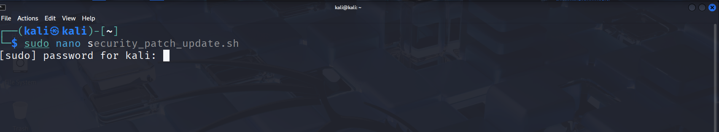

**Code:**

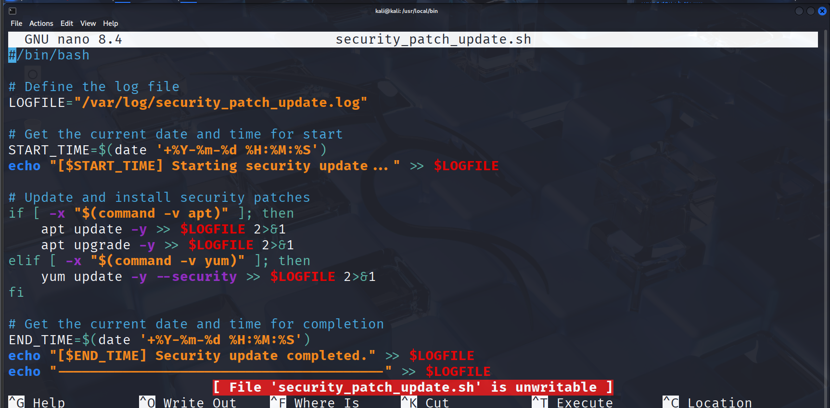

**Step 2:make the script executable**



**Step 3: Move Script to System Path and run using command**

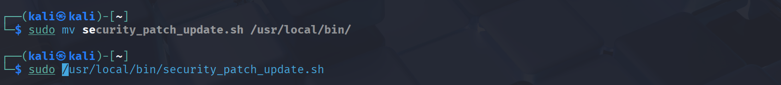

**Step 4:Schedule with Cron**

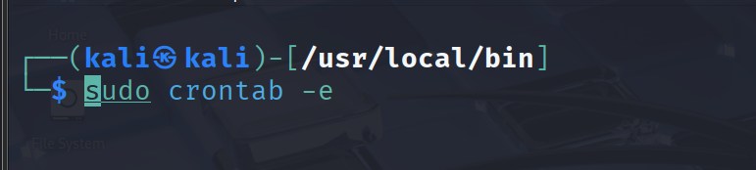

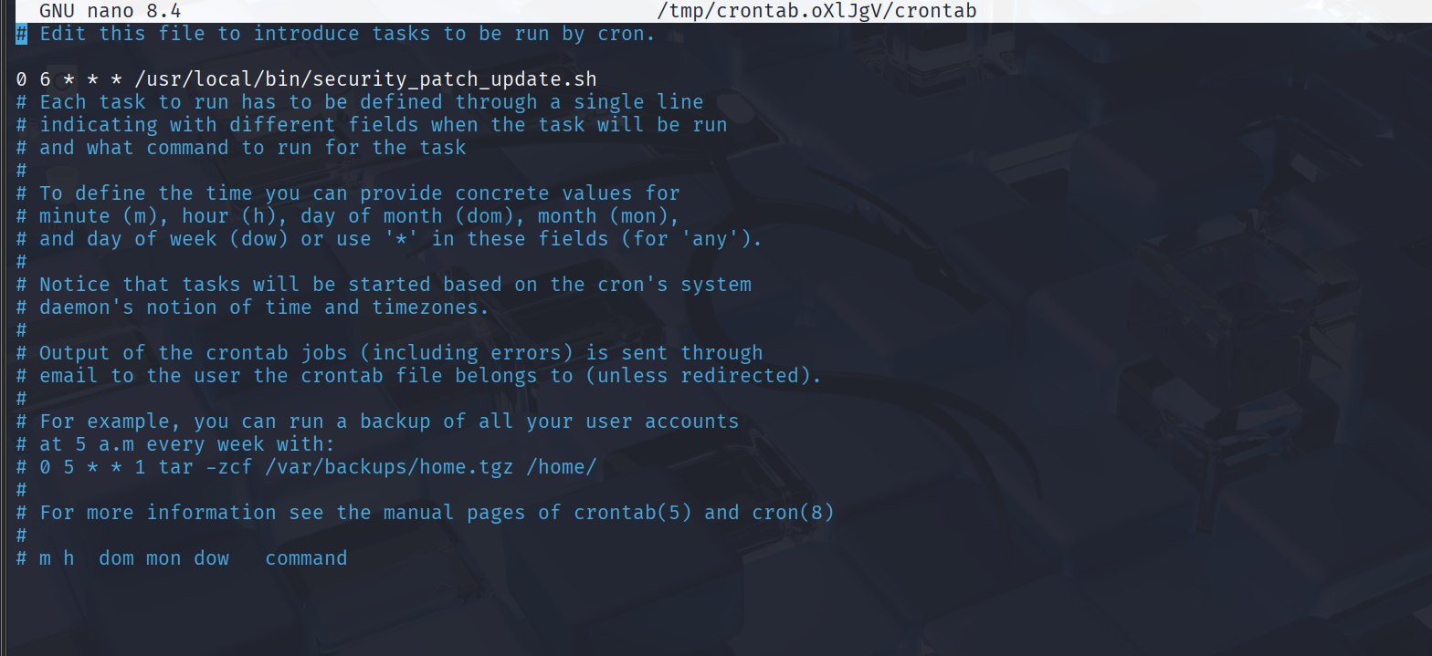

**Step 5: Setup Log Rotation**

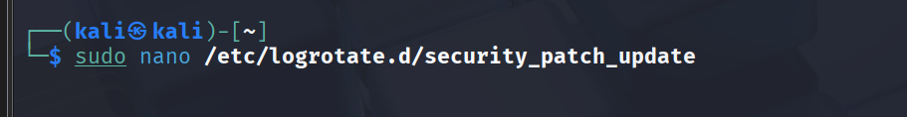

**The config :**

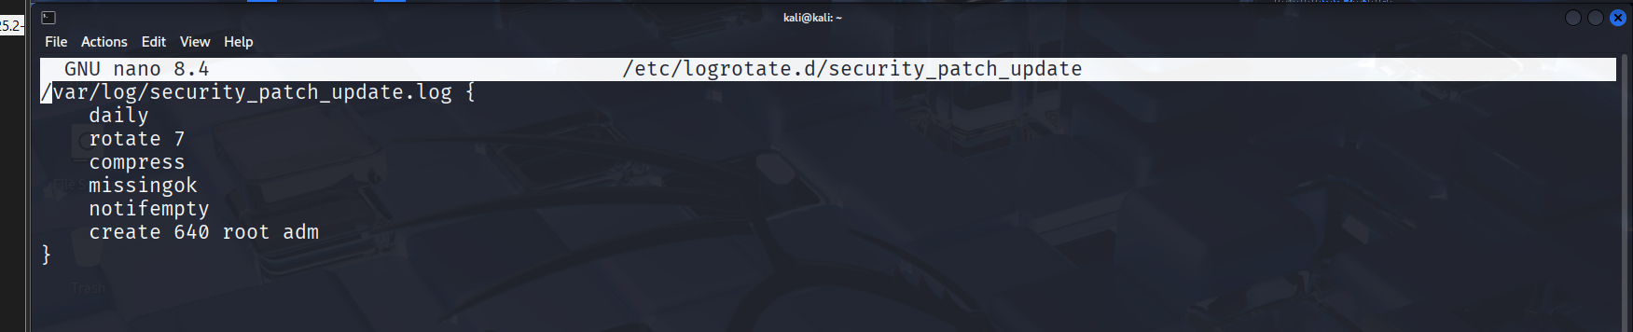

**Step 6: Test the Script**

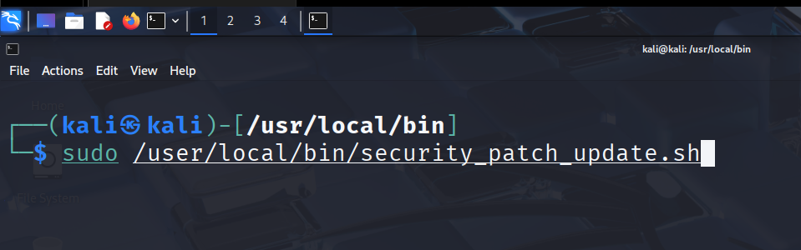

**Step 7 : Check the Log File**

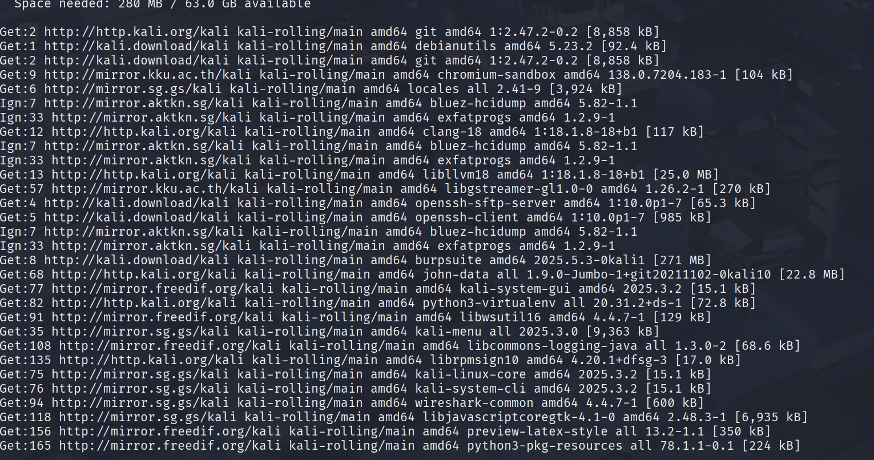

**Conclusion**

In today's world, keeping our systems updated is one of the simplest yet most effective ways to stay safe from cyber threats. Our project, the **Self-Updating Security Patch Script**, takes the hassle out of this essential task by automating the entire process. This means security updates are installed automatically, without you having to lift a finger.

Using tools like **cron** to schedule the updates, **apt** to install them on Kali Linux, and **log files** to record every change, we make sure your system is always protected. This approach eliminates the risk of human error, saves you a lot of time, and makes your security a lot more dependable.

Essentially, this project does three key things:

* It **prevents security risks** by applying patches as soon as they're available.
* It **runs automatically**, so you never have to remember to check for updates again.
* It **keeps a clear record** of everything for easy troubleshooting and transparency.

This solution is a simple, efficient, and crucial step toward better, more reliable system security management.